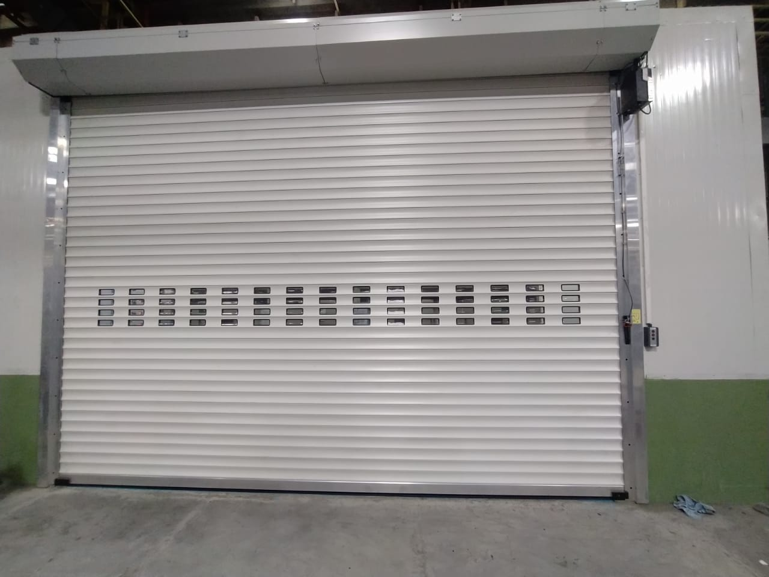
OPERATION & MAINTENANCE MANUAL FOR DOUBLE WALL ROLLING SHUTTER

CLIENT: M.A. ENGINEERING
PROJECT: JOHN DEERE INDIA PVT LTD
MFG.YEAR: 2020

DESIGNED, DEVELOPED & MARKETED BY



Address- G-BLOCK, 1ST FLOOR, THERMAX CHOWK MIDC, ABOVE RENAULT SHOWROOM CHINCHWAD, PUNE-411019
TEL.NO: - +912066304033
EMAIL: -info@nihva.com

www.nihva.com

PRODUCT - DOUBLE WALL MOTORIZED ROLLING SHUTTER
PRODUCT SIZE | 5000mm (CW) X 3560 mm (CH)
PO NO | MAE/217/20-21
PREPARED BY | SIDDHESHWAR SHELAKE
DATE | 21.12.2020

DESPATCH & UNLOADING

- Loading, for dispatch, will be our responsibility. On receipt of the Rolling Shutter at site, please check and ensure that there is no physical damage to the equipment.

- While unloading the equipment from the transporting vehicle, please ensure to use slings with rated capacity higher than the gross weight of the Stationary lift in packed condition.

ORDERING OF SPARES

  - When ordering for spare, please specify the following in your Purchase Order.

    - Shutter Size
    - Part name / Description
    - Quantity required
    - Delivery period / time
    - Mode of dispatch

This would avoid ambiguity and help us serve you better.

      - EMERGENCY CONTACT DETAILS: -

        - Service Department - 9168938333
        - Project Department - 8551095333

TECHNICAL DATA:

- SIZE: 5000X3560
- MANUFACTURING YEAR – 2020
- SPRING R – 057
- SPRING L- 058
- VOLTAGE – 230/240 V 1AC 50/60Hz
- POWER – 0.25kW
- RECOMMENDED MAINS VOLTAGE PRE-FUSE- 6A
- STAND-BY – APPROX 1 W
- PROTECTION CATEGORY- IP65
- NUMBER OF CYCLES- 10 CYCLES/HR
- TEMPERATURE RANGE - -20⁰C TO +60⁰C

INTRODUCTION: -

The Double wall Motorized Rolling Shutter is the result of many years’ experience in Door Automation Technologies. “NIHVA” offers the best possible factor of safety with simple, easy to use controls. The high quality of manufacture gives a robust construction and many years of useful life.

We take pride that our product & service range is offered with a high level of working safety, comfort, functionality and supported by services and added value solutions.

PRE – OPERATING INSTRUCTIONS: -

- The door system may only be operated by persons who have been instructed in its proper use.
- The door system opens & closes vertically upwards & downwards. When in operation, make sure that neither persons-children in particular- nor objects are located within the door’s area of travel.
- You are responsible for ensuring that children cannot operate door system , neither via the control nor control elements.
- Wait until the door has come to a complete halt before walking/driving into the door’s area of travel.
- Never use the door to lift objects and/or persons.
- Whenever driving in or out of the opening, always check that the door curtain has travelled up far enough to provide the necessary passage height.
- Only ever operate the door system when all the protective devices & safety equipment’s are fitted & are in perfect working order.
- Do not dismantle or alter any of the protective devices. Do not put any of the protective devices out of operation.
- Protect the door from aggressive & caustic substances in order to avoid damage due to incorrect handling of door system.
- The door system is intended for temperature range of -20⁰C to +60⁰C & relative humidity is 0% to 60%.
- In the case of malfunction call NIHVA immediately for inspect & repair the door system.
- Only use original spare parts. They always meet the technical requirements laid out by us.

OPERATING PUSH BUTTONS: -

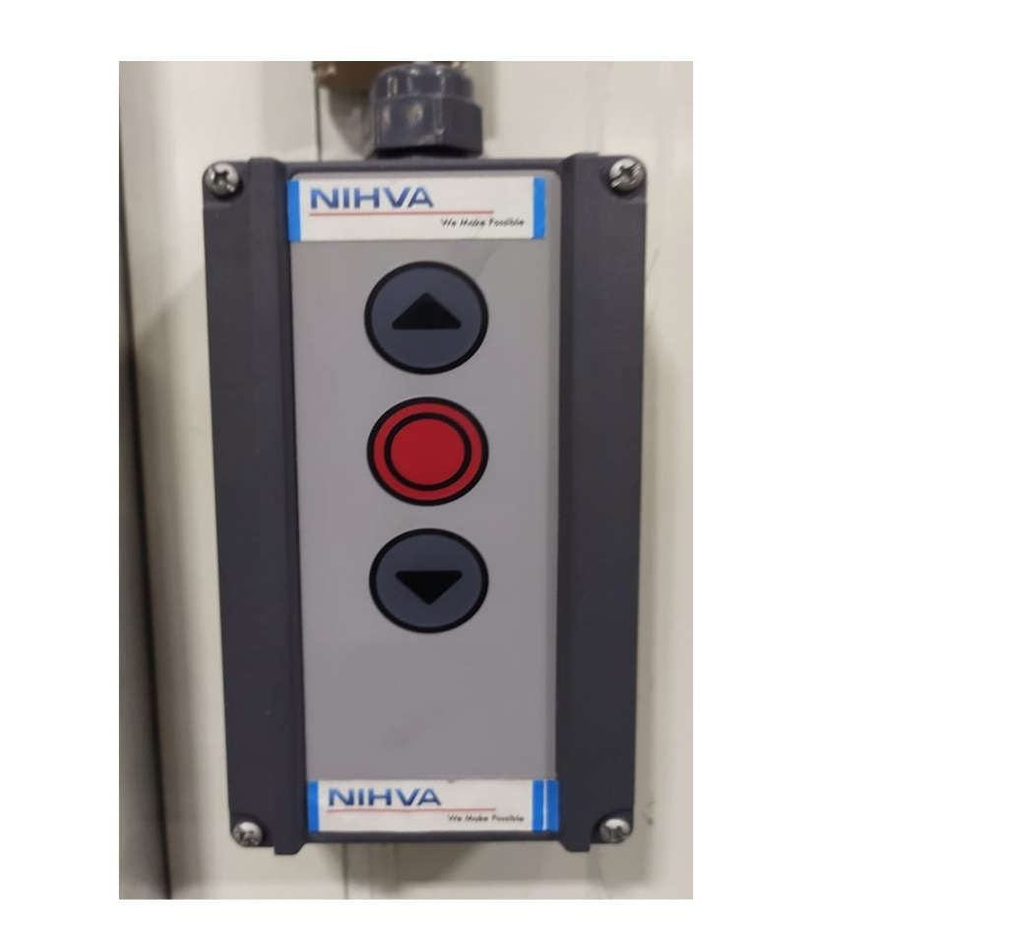
DOWN BUTTON
UP BUTTON
STOP BUTTON
ROUTINE MAINTENANCE

As the owner or operator of the door, you must have the system inspected & maintained by NIHVA/specialist once a year in. In the case of more than 50 door cycles a day, every 6 months.

DAILY:
- Do visual inspection for mechanical damage to product.
- Ensure proper voltage & all electrical connections are proper before operating.
- Clean the lenses & reflectors regularly with a soft, dry lint-free towel.

EMERGENCY OFF-
Proceed as follows during emergency off situations for doors with a WA 300 R s4:
- Pull out the CEE mains plug to disconnect from the power supply or
- Actuate the real main switch or the emergency-OFF button.

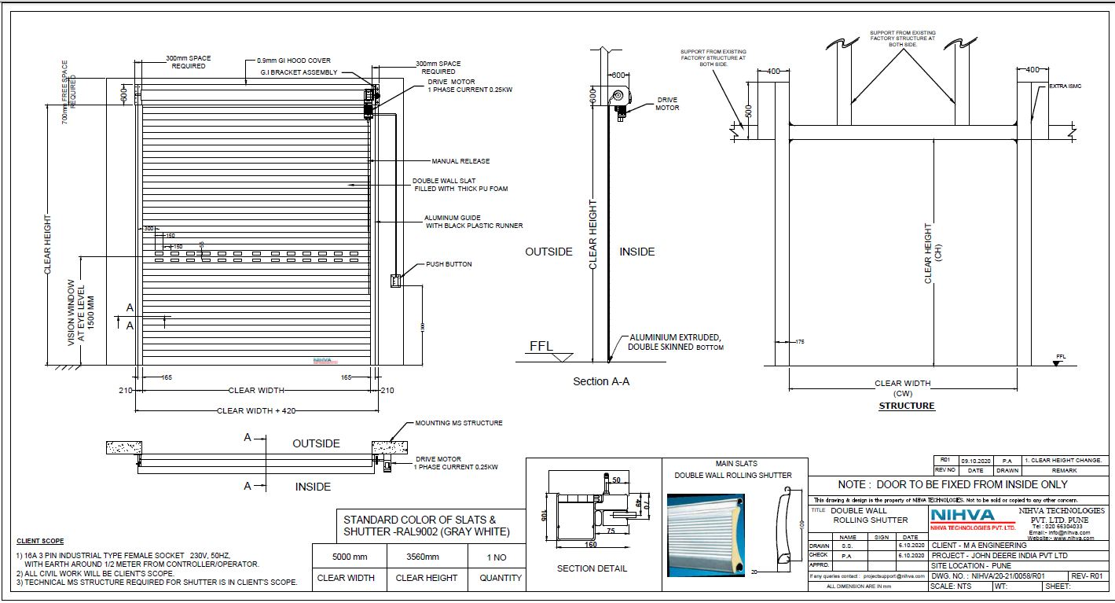
GA DRAWING:
STANDARD SPARES & ACCESSORIES-

- Door Curtain
- Support Bracket
- Side Guide
- Bottom Profile
- Bottom Seal
- Tension Spring
- Operator
- Push Button
- Vision Panel

